Motion assessment and Between-scan coregistration toolbox

This file includes documentation on how to use the new ‘between-scan registration’ of mrLoadRet-3.0. Here we explain the main functions of the toolbox and how to use them. For more information on the measures MSE and MI and the algorithms see the ppt slides.

- Files, directory structure

The relevant functions of this toolbox are stored in

VISTASOFT\mrLoadRet-3.0\Analysis\MotionComp\MI\

Most of the tools can be accessed from the mrLoadRet GUI in Analysis\Motion Compensation\Motion Compensation (MI). The next item in the Analysis menu, consecutive frame difference, helps in motion assessment (for example, before and after registration) by plotting various frame to frame errors.
Finally, an important feature of this toolbox is that it is scripted and can be run directly from the command line over night(s). Scripts are found in:

VISTASOFT\mrLoadRet-3.0\Analysis\MotionComp\MI\Scripts\

See the last section of this manual for the functionality of the various scripts available (this should also help you write your own scripts).

- Between-scan registration

The main function of this toolbox is called motionCompMutualInfMeanInit. It runs the between-scan registration algorithm in its general form. Here’s an example for calling this function from the command line:

view = motionCompMutualInfMeanInit(view, [scans], [ROI], [baseScan], newDataType, currentDataType, [rigid], [nonLinear]);

You can also run it from the GUI as follows:

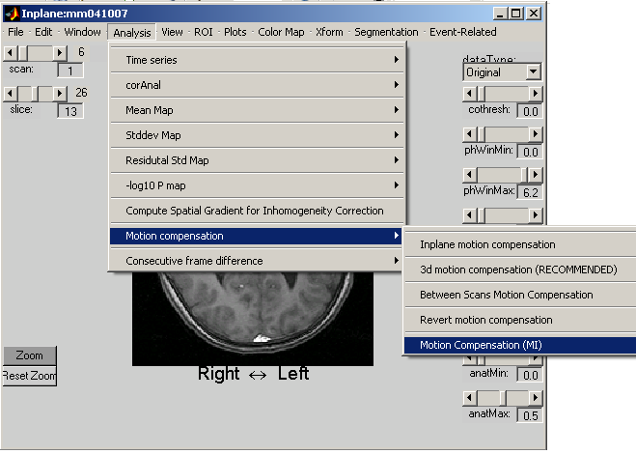

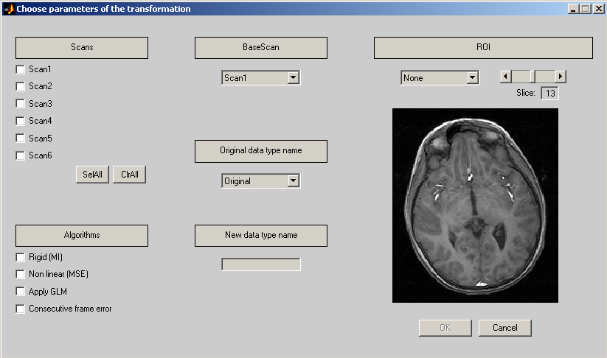

Input Arguments to motionCompMutualInfMeanInit:

- view: current inplane view. Can be created by typing:
mrVista
view = getSelectedInplane

- scans: scans to which the user wants to apply the transformation.

- ROI: the region of interest used for the rigid motion correction algorithm. It is loaded with the function motionCompGetROI either from the inplane view or from the ROI repository (directory subject/Inplane/ROI)

- baseScan: reference scan. If it is not defined or equal to 0, the anatomical data is taken as a reference.

- newDataType: name of the new data type name

- currentDataType: name of the data type the original images are taken from

- rigid: Indicates if the program calls the rigid transformation algorithm. Default: 0

- nonLinear: Indicates if the program calls the non linear algorithm. Default: 0

What does this function do?

1. Creates a new Data Type to store the new files of the corrected brain

A new time series is created for any scan checked in the GUI or passed in scans. Whenever a scan is not called by the algorithm, the time series corresponding to this scan is simply copied from the previous data type.

2. Runs a between-scan registration

This function computes the MEAN MAPS for each scan across all time frames, and then tries to find the best transformation to register those mean maps.

3. output:
- A log file called DataTypeLog.txt is saved in the subject’s dir.
- The ROI used and ROIdef (see below) are saved in ROIs dir
- a .avi file is created and saved, showing movie of the 18th slice through scans (you can change this slice selection by typing an argument in the call of the function motionCompMeanMovie).

- Scripts

To run a script over several datasets you will have to disable certain dialog boxes.
1. disable the “overwrite mrSESSION” box:
edit saveSession.m
in line 25 replace:
but = questdlg('Over-write existing mrSESSION file?');

with:
but = 'Yes';

Do not forget the capital “Y” in Yes.

2. Disable the dialog box shown when mrVista is launched (choose vAnatomy).
Edit mrVista
In line 38 comment out:

% vANATOMYPATH = getvAnatomyPath(mrSESSION.subject);

Available scripts (starting from the most general one):

Copyfiles : copies the subjects into a temporary directory and calls the script “register”. We use this to avoid overwriting good data with garbage. It can also speed up things if you have enough space to store files locally as a temporary storage.

Register : for every subject in the working directory, calls transformAll

TransformAll: Calls 4 transformations (creates 4 additional dataTYPEs for each subject):
- Rigid
- Non Linear
- Rigid + Non Linear
- Rigid Occ Lobes

Calls runMotionCompensation and ComputeError

runMotionCompensation : main function motionCompMutualInfMeanInit + GLM

computeError : computes the MSE and MI errors for all the dataTypes of the current subject

set parameters for scripts:

In Copyfiles, change or check

fileList
currentBatch
destinationDir
sourceDir
finalDir

It is usually preferable to start from small batches, and check the corrected brains. This means changing currentBatch (e.g. [1:3]).

In register, change or check

workDir (assigned twice because cleared after each subject. Check it in both places)

Once you have done all these modifications, you can run ‘copyfiles’ in the command line. This will compute 4 transformations for all the subjects you have put in the variable fileList (rigid only, Non linear only, Rigid + Non_linear, Rigid with an ROI on the occipital lobes)

The scripts copyfiles consists of 3 steps :

- It copies the files from the load directory to the temporary directory (It takes a long time and it can be done directly on the shell of the OS)

- It calls the script register which applies the 4 transformations to all the subjects in the temporary directory.

- It copies the transformed subjects into the save directory.

These 3 steps are executed in this order. This means that you can do it manually if you want to. You could for example:

- Copy the files by yourself into one of your directory.

- Change the name of the temporary directory in the file named register

- Type register in the matlab command line

- Copy the transformed files in the directory you want

Interpolation methods:

Once a transformation between mean maps has been computed, each frame has to be resliced. Because the transformation is a continuous transformation, the mapping between source and target voxels is not perfect. So we need an interpolation to compute the resliced image.

We consider two ways of interpolating data. The first one is trilinear interpolation. It consists of an interpolation of a polynomial of order 1 between the surrounding neighbors. The other one called spline interpolation is based on a more precise polynomial fitting (order 7). More complicated interpolation schemes (e.g. spline) are more time consuming than simpler ones (trilinear, nearest neighbor) but have other advantages (spline introduces less smoothing than trilinear).

This is how we change interpolation methods for now (note that it’s a separate change for each registration method (rigid / non linear)). Currently both should default to spline (but its worth checking before you run).

Rigid
In mrSpm_rotateFrame:
To have spline interpolation, comment the redefinition of bSplineParams line 48
% Linear interpolation
% bSplineParams = [1 0; 1 0; 1 0];

Conversely, to have trilinear interpolation, uncomment that second assignment:
% Linear interpolation
bSplineParams = [1 0; 1 0; 1 0];

Non Linear
In motionCompApplyTransform:

To have spline interpolation uncomment the “motionCompInterpolate” command line 38
% spline interpolation order 7
TnewLuebeck = motionCompInterpolate(TLuebeck,ux,uy,uz,7);

To have linear interpolation, uncomment the “trilin” command line 35
% Linear interpolation
TnewLuebeck = trilin(TLuebeck,ux,uy,uz);

Note that if both of them are uncommented you will get spline on (second assignment).

